Category-Informative
Company-General Technical
Keyword: How to Set Default Email Address in Mail for Mac OS X

Keywords:
default email address in mac OS X, How to Specify the Default Account in Mac OS X Mail, Alter Default Account in Mac OS X Mail, how to set default email account on mac, apple mail default email account, how to set default email account on mac, change default email address mac

How to Set Default Email Address in Mail for Mac OS X

Mac Mail is a popular email application used by almost all Apple users. Most of the users also configure their Mac Mail with different email addresses for quick access. Users often use one email address more than the others and can set it to be their default account. This way, they will be able to send emails faster, without having to choose each time. So, in this blog, the method of how to set default email address in Mail for Mac OS X is explained.

Reasons to Have a Default Email Address in Mac OS X

As explained, users send more emails from a particular email account. To save time and energy, they can set default email account on Mac. Apple Mail automatically selects the topmost email address to be the one through which all mails are sent. Users mistakenly send emails from the wrong account. It can be unprofessional, and embarrassing in some cases as observed from this user query:

“I access three email addresses from Mac Mail. Two of them are work Ids, and one is my personal email account. Every time I send an email, its goes from one of my work email addresses. I have to remember to select the personal account from the drop-down list every time I want to send it correctly. Is there some way to set my personal email account as the Apple Mail default email account? Then I would not have to constantly choose from the drop-down box?”

Steps to Set Default Email Address in Mac OS X
As seen above, users have been known to send mails through the incorrect email address. Therefore, it is preferable to set a default mail to avoid mistakes and save some time. How to set default email address in Mail for Mac OS X is elaborated below:
- Open Mac Mail. From the top ribbon, go to Mail<<Preferences.
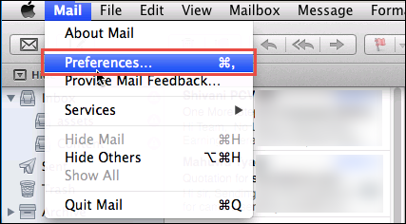

- Go to the Composing tab.
- In the Addressing section, under Send new messages from, select your default email address from the drop-down list.
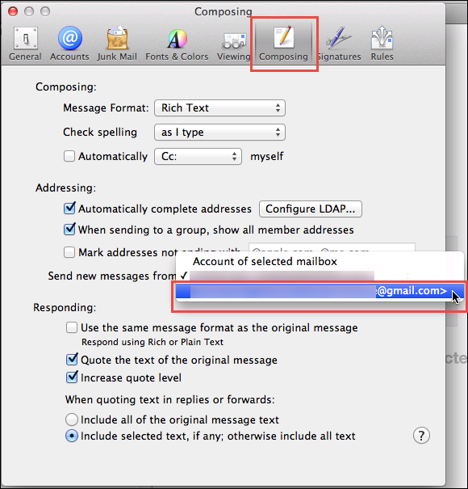

- Close the Composing menu.
The default email address is successfully set. The next time a new email is composed, it shows the default email account in the sender column.

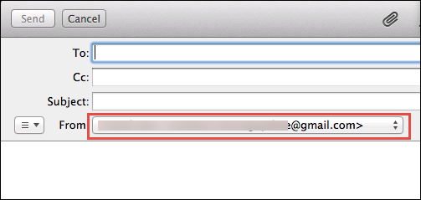

Method to Alter Default Account in Mac OS X Mail
The procedure of changing the default email address is similar to setting a default email account. They are:
- When you open the Composing menu, in the Addressing>>Send new messages from section, it shows the Apple default email account. It is the one on top of the drop down list, with a tick-mark before it.
- Select the new default email address from the list, and close the menu.

Initial Inbox Default in Mac Mail

If a default email address is not expressly set, Mac OS X mail automatically displays the Inbox for one email ID first. In Mac Mail, the topmost account is selected as the default account for outgoing mails. Now, the complete order of all accounts can be changed using drag-and-drop method. Drag the account address from the left pane up, and drop it at the top. All emails of different addresses under Inbox, also are sorted in this order.

Advantages of a Default Mac Email Addressing
There are many reasons why users prefer to make one email address as the default one. Some are mentioned below:
- Saves the effort of repeatedly selecting the correct email account.
- Shorter mailing time, as preferences are set for daily use.
- Guards against accidental incorrect emailing and subsequent embarrassment.

That said, there are times when an email has to be sent through an email server other than the default account. That is also explained next.

Method to Shortly Switch from Default Outgoing Email Address
Sometimes users want to switch from the Apple mail default email account for that particular message. It can be changed while composing a new email in the following manner:
- Click the email account through the From line.
- Choose the desired email address from the drop-down list and Select it.
Continue writing the new email in the same manner as always. This email will be sent through the selected server now.

Conclusion

Sometimes when more than one email account is configured with Mac mail, users have to repeatedly select the email account correctly. Since Mac Mail lets the user set his own preferences in all manner possible. He can utilise this by setting a default email account for his outgoing messages. It could be any an email ID that is used most often. Once the default is set, it saves precious time and effort. In this blog, the steps of how to set default email address in Mail for Mac OS X were explained. If need arises, the user can change the outgoing email account while composing his email. If you have any queries related to setting a default Mac mail account, leave a comment and we will try to resolve it at the soonest.

